

INFORMATICS INSTITUTE OF TECHNOLOGY

In collaboration with

UNIVERSITY OF WESTMINSTER

Programming Principles II

4COSC010C

Coursework 2

Online Music Store

Module Leader’s Name – Mr. Guhanathan Poravi

Dinuka Piyadigama

UoW ID – 17421047

IIT ID – 2018373

Contents

Design 3

Functional & Non-functional Requirements 3

Functional Requirements 3

Non-Functional Requirements 3

Use Case Diagram 4

Use Case Description 4

Class Diagram 12

Activity Diagrams 12

Add item 12

Delete item 13

Print list of items 13

Sort list of items 14

Buy items 15

Generate File 16

GUI 17

Testing 18

Black-box testing 18

White-box testing 20

Code Coverage testing 20

White-box testing chart 22

# Design

## Functional & Non-functional Requirements

### Functional Requirements

1. The system should be able to hold up to 1000 items in total.
2. The system should be able to hold information about the music items (id, title, genre, release date, artist, price, etc.).
3. The system should be able to identify the date of when the item has been released.
4. The manager should be able to insert up to 1000 items in total.
5. The manager should be able to select whether he wants to enter a CD/ a vinyl when entering records.
6. The system should be able to display the number of spaces left, whenever a manager enters an item.
7. The manager should be able to delete an item by inputting the item ID.
8. The system should be able to display the type of the item that has been deleted and the number of free spaces left, whenever a manger deletes an item.
9. The manager should be able to request to print the list of items in store.
10. The system should be able to print the list of items in store (id, type of the item, title).
11. The system should be able to sort the list of items in ascending order of title.
12. The user should be able to buy an item by selecting the item ID.
13. The user should be able to request for more than one copy of an item from the system.
14. The system should be able to display the total cost of selected items.
15. The system should be able to generate a report into a file with details of all the items that have been sold, whenever a user purchase items.
16. The user should be able to request for a GUI as an option from the menu console.
17. The system should be able to display the list of items in store with the main information, in a table.
18. The user should be able to search for a specific item by title.
19. The system should be able to display the item searched by the user.

### Non-Functional Requirements

1. Performance – The system should be able to display all requested output within 5s.
2. Security – The user shouldn’t be able to modify the records of items.
3. Accuracy –
   1. The system should be able to accurately calculate the total cost of items selected by the user.
   2. The system should be able to accurately chose records & options related to whatever item selected by the user/ the manager.
4. Reliability –
   1. The system should be able to run without causing any errors.
   2. The system should be able to store the relevant input in the relevant datatype.
5. Usability and user-friendliness –
   1. If an incorrect parameter is entered by the user, the system should be able to handle errors.
   2. Displaying a menu that clearly states the function of the options displayed.
   3. Clearly displaying the output in the GUI.
6. Reusability – Ability to input purchase reports into one file.

## Use Case Diagram

## Use Case Description

**Online Music Store Management System**

|  |  |
| --- | --- |
| Use Case ID | 01 |
| Use Case Name | Add new item |
| Use Case Description | Adding a new item into the music store |
| Actors | Manager |
| Pre Condition | 1. Display available managerial options. 2. The manager must’ve selected the “add new item” option. |
| Post Conditions | The manager should get the option to choose between a new CS item/ a new Vinyl item. |
| Path |  |
| Primary Path | 1. The manager requests the system to add a new item    1. The system requests the manager to choose whether to add a CD or a Vinyl |
| Alternate Path | n/a (not applicable) |
| Exception Path | n/a (not applicable) |
| Assumption | n/a |

|  |  |
| --- | --- |
| Use Case ID | 02 |
| Use Case Name | Add CD |
| Use Case Description | Adding a new CD item into the music store |
| Actors | Manager |
| Pre Condition | The manager must’ve selected the “Enter CD” option. |
| Post Conditions | 1. The system should save the added item with its information |
| Path |  |
| Primary Path | 1. The manager adds all the required information of the new CD   2.1 The system saves the information relevant to the CD.  2.2 The main menu is re-prompted. |
| Alternate Path | n/a (not applicable) |
| Exception Path | n/a (not applicable) |
| Assumption | n/a |

|  |  |
| --- | --- |
| Use Case ID | 03 |
| Use Case Name | Add Vinyl |
| Use Case Description | Adding a new Vinyl item into the music store |
| Actors | Manager |
| Pre Condition | The manager must’ve selected the “Enter CD” option. |
| Post Conditions | 1. The system should save the added item with its information |
| Path |  |
| Primary Path | 1. The manager adds all the required information of the new Vinyl   3.1 The system saves the information relevant to the Vinyl.  3.2 The main menu is re-prompted |
| Alternate Path | n/a (not applicable) |
| Exception Path | n/a (not applicable) |
| Assumption | n/a |

|  |  |
| --- | --- |
| Use Case ID | 04 |
| Use Case Name | Delete Item |
| Use Case Description | Delete a selected item form the music store |
| Actors | Manager |
| Pre Condition | 1. Items should have been added to the music store  2. Display available managerial options.  3. The manager should have selected the “delete item” option from the main menu  4. The main menu is prompted |
| Post Conditions | All the information related to the item chosen is deleted |
| Path |  |
| Primary Path | 4.0 The system prompts for an ‘item ID’ to be deleted  4.1 The manager enters an item ID  4.2 The system deletes the entry related to the CD  4.2 The system displays the number of remaining spaces  4.3 The system displays the type of the item that has been deleted  4.4 The system re-prompts the main menu |
| Alternate Path | 4.0 & 4.1 have been completed  4.2 The system deletes the entry related to the Vinyl  4.3, 4.4 are executed |
| Exception Path | 4.0 & 4.1 have been completed  4.2 The system displays that there is no related entry to the item ID entered. |
| Assumption | When an item is deleted, all information relevant to that item is deleted |

|  |  |
| --- | --- |
| Use Case ID | 05 |
| Use Case Name | Identify remaining spaces |
| Use Case Description | The manager should be able to identify the remaining number of free spaces in the music store |
| Actors | Manager |
| Pre Condition | The manager should have added an item to/ deleted an item from the music store. |
| Post Conditions | The main menu should be re-prompted |
| Path |  |
| Primary Path | 5.0 The system displays the remaining number of spaces |
| Alternate Path | 5.0 The system displays a message that there are no available spaces |
| Exception Path | n/a (not applicable) |
| Assumption | The system can keep track of the count of the number of items entered. |

|  |  |
| --- | --- |
| Use Case ID | 06 |
| Use Case Name | Enter Item ID |
| Use Case Description | Entering the item ID of item to be chosen |
| Actors | Manager, Customer |
| Pre Condition | 1. Items should have been added to the music store  2. Display available managerial options. |
| Post Conditions | 1. The item chosen should be deleted with its information  2. Display the number of remaining spaces  3. Display the type of the item that has been deleted |
| Path |  |
| Primary Path | 4.0 The manager selects the “Delete item” option from the main menu  4.1 The system prompts for an ‘item ID’ to be deleted  4.2 The manager enters an item ID |
| Alternate Path | 4.0 The manager selects the “Buy item” option from the main menu  4.1 The system prompts for an ‘item ID’ to be bought  4.2 The user (manager/ customer) enters an item ID |
| Exception Path | n/a (not applicable) |
| Assumption | n/a (not applicable) |

|  |  |
| --- | --- |
| Use Case ID | 07 |
| Use Case Name | Print list of items |
| Use Case Description | Printing the list of items in-store, with their information |
| Actors | Manager |
| Pre Condition | 1. Items should have been added to the music store  2. Display available managerial options.  3. The manager should have selected the “print list of items” option from the main menu  4. The main menu is prompted |
| Post Conditions | The information is clearly read and understood by the manager |
| Path |  |
| Primary Path | 7.0 The system displays the item ID, type of item and the title of all the items in store |
| Alternate Path | n/a (not applicable) |
| Exception Path | n/a (not applicable) |
| Assumption | The manager can read the information displayed |

|  |  |
| --- | --- |
| Use Case ID | 08 |
| Use Case Name | Sort items in ascending order |
| Use Case Description | Sorting the items in ascending order of title |
| Actors | Manager |
| Pre Condition | Items should have been entered and stored. |
| Post Conditions | Sorted items should be retrievable |
| Path |  |
| Primary Path | 8.0 The user requests to sort items  8.1 The system sorts items in ascending order. |
| Alternate Path | n/a (not applicable) |
| Exception Path | n/a (not applicable) |
| Assumption | Items are always sorted in ascending order |

|  |  |
| --- | --- |
| Use Case ID | 09 |
| Use Case Name | Open GUI |
| Use Case Description | Opening the Graphical User Interface, to see all the information for each item |
| Actors | Manager |
| Pre Condition | Items have been entered and stored. |
| Post Conditions | The information is clearly read and understood by the manager |
| Path |  |
| Primary Path | 9.0 The manager requests to open the GUI.  9.1 The GUI is opened by the system  9.2 The system shows the list of items in store with the main information. |
| Alternate Path | n/a (not applicable) |
| Exception Path | n/a (not applicable) |
| Assumption | All the information added to the system can be accessed by the GUI |

|  |  |
| --- | --- |
| Use Case ID | 10 |
| Use Case Name | Search for item by title |
| Use Case Description | Information regarding items can be searched by title |
| Actors | Manager |
| Pre Condition | 1. Items have been entered and stored.  2. The GUI must be open. |
| Post Conditions | 1. The information is clearly read and understood by the manager  2. The information relevant to the item searched remains in the system. |
| Path |  |
| Primary Path | 10.0 The system gives the option to search for an item’s information by prompting for the item title.  10.1 The manager enters the item title of the item required to be found.  10.2 The system displays information relevant to the item chosen. |
| Alternate Path | n/a (not applicable) |
| Exception Path | n/a (not applicable) |
| Assumption | All the information added to the system can be accessed by the GUI |

|  |  |
| --- | --- |
| Use Case ID | 11 |
| Use Case Name | Buy item |
| Use Case Description | Selecting items to buy |
| Actors | Manager / Customer |
| Pre Condition | 1. Items have been entered and stored.  2. The main menu is displayed by the system |
| Post Conditions | The required quantity of the chosen item is prompted by the system. |
| Path |  |
| Primary Path | 11.0 The system prompts the user to choose an option from the main menu  11.1 The user (manager/ customer) chooses the “Buy item” option.  11.2 The system prompts the user to enter the item ID of the required item.  11.3 The user (manager/ customer) enters the item ID of the required item. |
| Alternate Path | n/a (not applicable) |
| Exception Path | n/a (not applicable) |
| Assumption | There’s an adequate number of items in store |

|  |  |
| --- | --- |
| Use Case ID | 12 |
| Use Case Name | Buy more than one copy |
| Use Case Description | Selecting more than one copy of an item, to buy |
| Actors | Manager / Customer |
| Pre Condition | 1. Items have been entered and stored.  2. The user (manager/ customer) has chosen the “Buy item” option from the main menu. |
| Post Conditions | The system uses the information of the purchased item, to generate a report |
| Path |  |
| Primary Path | 12.0 The system prompts the user whether more than one copy of the item chosen is required.  12.1 The user (manager/ customer) enters the requirement (yes/ no) |
| Alternate Path | n/a (not applicable) |
| Exception Path | n/a (not applicable) |
| Assumption | There’s an adequate number of items in store |

|  |  |
| --- | --- |
| Use Case ID | 13 |
| Use Case Name | Enter number of copies |
| Use Case Description | Entering the number of copies of the item chosen. |
| Actors | Manager / Customer |
| Pre Condition | The user (manager/ customer) has chosen the option to buy more than one copy |
| Post Conditions | 1. The total cost of all the items chosen will be displayed.  2. The system uses the information of the purchased item, to generate a report |
| Path |  |
| Primary Path | 13.0 The system prompts the user to enter the number of copies required.  13.1 The user (manager/ customer) enters the number of copies required.  13.2 The system adds up the copies into the shopping cart.  13.3 The system calculates the total cost of items in the shopping cart. |
| Alternate Path | 13.0 has been completed.  13.1 the user (manager/ customer) enters ‘1’ as the number of copies required.  13.2 The system adds one copy into the shopping cart.  13.3 The system identifies the cost of a chosen item as the total cost. |
| Exception Path | 13.0 has been completed  13.1 The user (manager/ customer) enters ‘0’ as the number of copies required.  13.2 The system doesn’t add any copy of the chosen item into the shopping cart  13.3 The system assigns the total cost to be zero. |
| Assumption | There’s an adequate number of copies of the chosen item as requested, in store |

|  |  |
| --- | --- |
| Use Case ID | 14 |
| Use Case Name | Generate report |
| Use Case Description | Generating a report of the items bought |
| Actors | Manager/ customer |
| Pre Condition | The user (manager/ customer) should have purchased at least one item |
| Post Conditions | A file is written with the information provided to generate the report. |
| Path |  |
| Primary Path | 14.0 The user (manager/ customer) buys an item  14.1 The system writes the title, ID, price & selling time/date into a file |
| Alternate Path | n/a (not applicable) |
| Exception Path | n/a (not applicable) |
| Assumption | All the information added to the system can be accessed by the GUI |

## Class Diagram

## Activity Diagrams

### Add item

### Delete item

### Print list of items

### Sort list of items

### Buy items

### Generate File

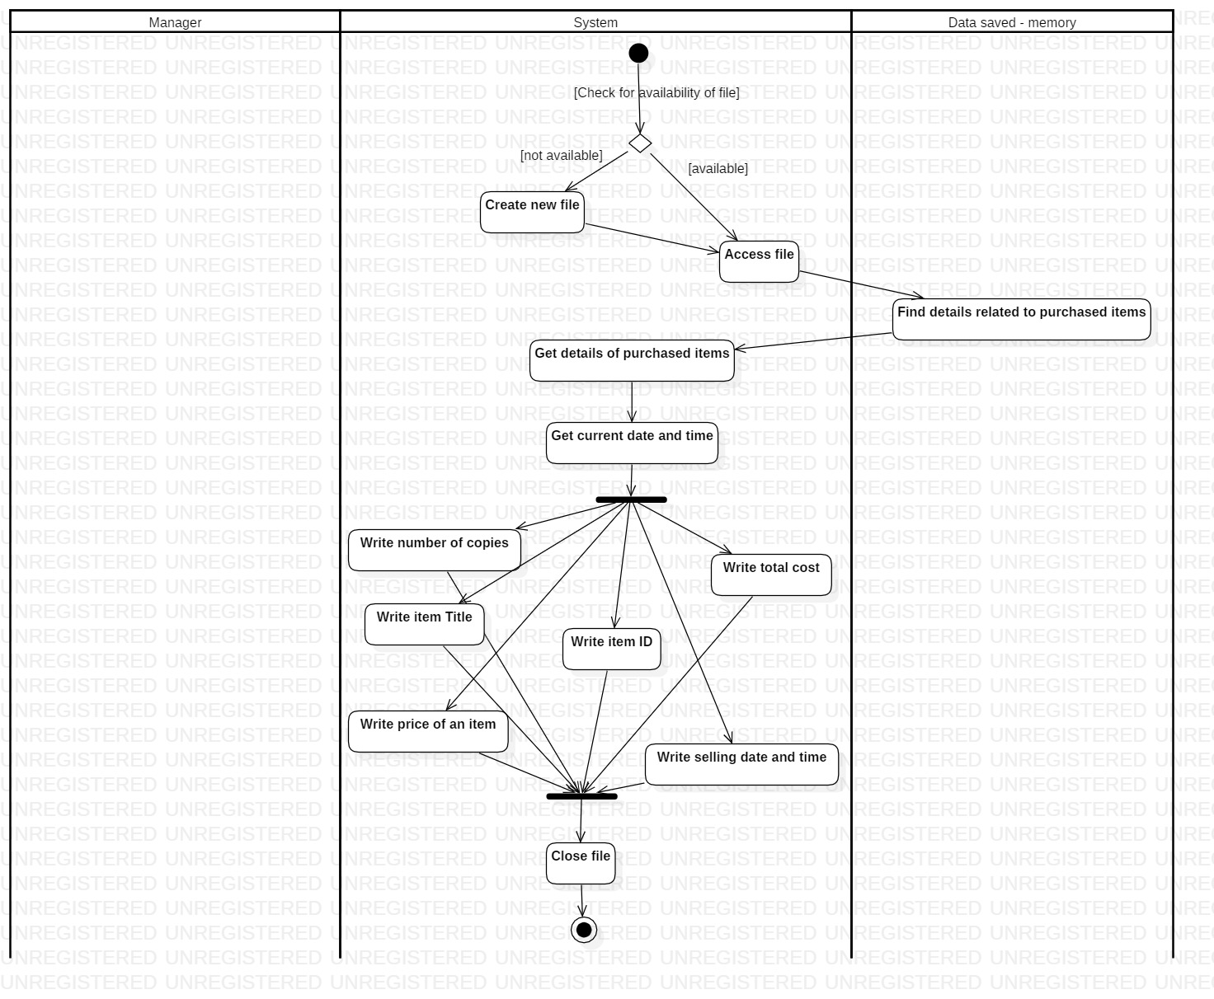

### GUI

# Testing

## Black-box testing

|  |  |  |  |  |  |
| --- | --- | --- | --- | --- | --- |
| Test Case ID | Test Case | Input | Expected Output | Observed Output | Status |
| 1 | Add item | 1 | Prompt to choose an item type | Prompt to choose an item type | Pass |
|  |  | 2 | Prompt to enter an item ID | Prompt to enter an item ID | Pass |
|  |  | 8 | Error message and re-prompt for input | Error message and re-prompt for input | Pass |
|  |  | 0 | Pass |
|  |  | -3 | Pass |
|  |  | g | Pass |
| 2 | Choose item type to add | @ | Error message and re-prompt for input | Error message and re-prompt for input | Pass |
|  |  | j | Pass |
|  |  | 9.0 | Pass |
|  |  |  |  |  |  |
| 3 | Choose item type to add | 1 | User is prompted to input information about a CD | User is prompted to input information about a CD | Pass |
|  |  | 2 | User is prompted to input information about a Vinyl | User is prompted to input information about a Vinyl | Pass |
|  |  | h | Error message and re-prompt for input | Error message and re-prompt for input | Pass |
|  |  | 5 | Pass |
|  |  | -3 | Pass |
|  |  | # |  |
|  |  |  |  |  |  |
| 4 | Enter Date | 32/1/2019 | Day is set to 1  Date entered is: 1/1/2019 | Day is set to 1  Date entered is: 1/1/2019 | Pass |
|  |  | 31/1/2019 | Date entered is: 31/1/2019 | Date entered is: 31/1/2019 | Pass |
|  |  | 29/2/2019 | Day is set to 1 | Day is set to 1 | Pass |
|  |  | 29/2/2020 | Date entered is: 29/2/2020 | Date entered is: 29/2/2020 | Pass |
| 5 | Enter day OR month OR year of date | 7.6 | Display Error message and re-prompt for input | Display Error message and re-prompt for input | Pass |
|  |  |  |  |  |  |
| 6 | Buy item | 7, No | Display total cost | Display total cost | Pass |
| 7 | Choose number of copies to buy | 3.0 | Display Error message | Display Error message | Pass |
|  |  | 3 | Display total cost | Display total cost | Pass |
|  |  |  |  |  |  |
| 8 | Generate file upon purchase | Item ID = 7,  No. of copies= 2 | Write item ID =7, title, price, copies, total cost and selling date/time in the specified file | Write item ID =7, title, price, copies, total cost and selling date/time in the specified file | Pass |
|  |  |  |  |  |  |
| 9 | Search item in GUI by title | Hello | Display all information relevant to this item in the table, if available in store | Display all information relevant to this item in the table, if available in store | Pass |

## White-box testing

### Code Coverage testing

#### Second run

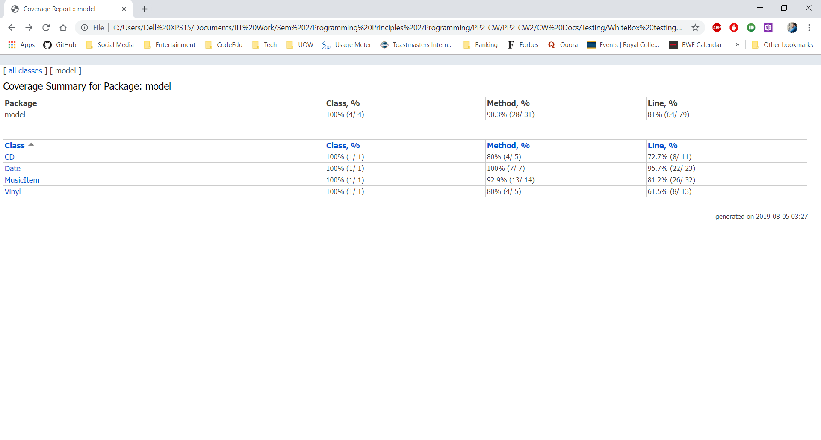

#### First-run

### White-box testing chart

|  |  |  |
| --- | --- | --- |
| Test ID | Test Case | Status |
| 1 | The cloud database gets connected to the program when the program starts. | Pass |
| 2 | Import items saved in the database, when the program starts | Pass |
| 3 | Display main menu | Pass |
| 4 | Prompt user to choose an option from the main menu | Pass |
| 5 | Add item option prompts the user to choose the type of the item to be added | Pass |
| 6 | If CD type was chosen to be added; item ID, title, genre, release date, artist, price and duration are prompted sequentially | Pass |
| 7 | If Vinyl type was chosen to be added; item ID, title, genre, release date, artist, price, speed and diameter are prompted sequentially | Pass |
| 8 | When an item is added to the system, its information gets saved in the cloud database as a document (noSQL – MongoDB Atlas) | Pass |
| 9 | When adding items, if an item ID that already exists in store is entered, the user is notified that the item ID has already been taken and the user is prompted for a different item ID. | Pass |
|  |  |  |
| 10 | Once the chosen task is completed, the main menu is re-prompted | Pass |
|  |  |  |
| 11 | Delete item option prompts the user to enter an item ID that the user requires to delete | Pass |
| 12 | If item ID entered is of an item in store, all the information related to the item gets deleted from the system and the cloud database (MongoDB Atlas) | Pass |
| 13 | Whenever an item is added to/ deleted from the system, the number of free spaces left in the store is displayed | Pass |
|  |  |  |
| 14 | Print list of items option displays all the items in store with their item IDs, types and titles in a table format. | Pass |
| 15 | Sort items option sorts the stored items in ascending order of title and saves all the items in this order | Pass |
| 16 | When printing the list of items/ displaying them in the GUI, items are displayed in the sorted order, after sort items option is chosen. | Pass |
| 17 | Whenever new items are added, they are added to the end of these tables |  |
|  |  |  |
| 18 | Buy item option prompts the user to enter an item ID of the item that the user desires to purchase | Pass |
| 19 | If the item that the user requests exists in store, the user is prompted whether more than one copy of the item chosen is required | Pass |
| 20 | If the user chooses to buy more than one item, the number of required copies is prompted | Pass |
| 21 | Once the user enters the number of copies required, the total cost of all purchased items is calculated and displayed | Pass |
|  |  |  |
| 22 | When a purchase is completed through the buy item option, a report is generated in file. | Pass |
| 23 | The title, item ID, price, total cost, selling date/time are saved in the file generated upon completion of purchase. | Pass |
|  |  |  |
| 24 | If the item ID entered in delete item and buy item options isn’t found in the system, the user is notified that there’s no such item in store. | Pass |
|  |  |  |
| 25 | Open GUI option opens the Graphical User Interface in a separate window | Pass |
| 26 | All the information of the items in store are displayed in a JavaFX table component format | Pass |
| 27 | Items can be searched by Title in a search box displayed in the GUI | Pass |
| 28 | When Reset button is clicked in the GUI, all the items in store are displayed in the table and the search field is emptied | Pass |
|  |  |  |
| 29 | If the user tries to enter more than 1000 items, the system notifies the user that there’re no available spaces to store new items | Pass |
| 30 | Exit program option in the main menu, ends the program | Pass |